Variables and command line arguments
- $0 - The name of the script
- $1 - $9 - Any command line arguments given to the script: $1 is the first argument, $2 the second and so on
- $# - How many command line arguments were given to the script.
- $* or $@ - All of the command line arguments passed to the script ($* returns a string, $@ returns an array).
- $? - The exit status of the most recently run process
- $$ - The process ID of the current script
- $USER - The username of the user running the script
- $HOSTNAME - The hostname of the machine the script is running on
- $SECONDS - The number of seconds since the script was started
- $RANDOM - Returns a different random number each time is it referred to
- $LINENO - Returns the current line number in the Bash script
- $PATH – Returns command’s directory.
- $SHELL – Returns default shell directory.

Single quotes VS double quotes
- ‘Single quotes’ will treat every character literally
- “Double quotes” will allow you to do substitution

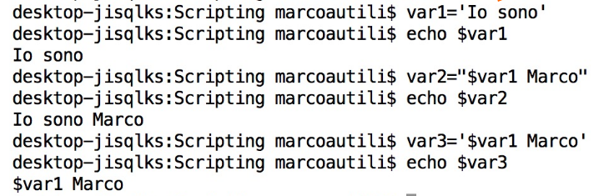

Variables declaration
You can declare a variable by using declare or typeset command.
Most used options are:
- -r : set the variable to only read variable
- -i : declare an integer variable
- -a : declare an array variable
Syntax:
declare [options] [variable_name[=value]]
typeset [options] variable_name[=value]]
Variables length
${#variable} – the length of the variable in terms of numbers of characters
Examples:
a='Marco'
${#a} is equal to 5
b=1024
${#b} is equal to 4

Here String Redirection
[n] <<< string

The string becomes the input for a command or a variable. All substitutions are made before they are given to the command.

